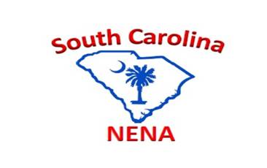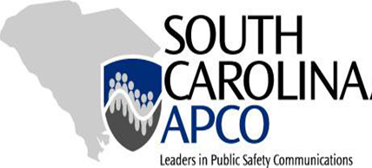

***CALL FOR SPEAKERS/PRESENTERS***

The annual South Carolina APCO/NENA fall conference is the foremost networking and educational event in South Carolina for Public Safety Communications professionals.  This year the conference is being held October 5th-7th, 2021 at the Marriott Myrtle Beach at Grande Dunes in Myrtle Beach, SC and we are placing an emphasis on opportunities that are presented to Telecommunicators and Supervisors through training and leadership.

We invite you to submit a proposal for a 45-minute to one-hour presentation to share your expertise with fellow emergency communications Professionals.  Your presentations should be relevant training for 911 center operations, leadership training, or the public safety communications industry.  Your submission should provide the following information and will need to be submitted **no later than July 29, 2022**:

1. Name of the presenter with short bio
2. Agency or organization
3. Phone number
4. Email address
5. Name of the training and a PowerPoint presentation
6. Amount of time needed for class
7. Overall summary of the presentation (100 words or less)

Please submit your information to the link below:

[Submission Link](mailto:wrooney@spartanburgcounty.org;%20brandon.peeler@cherokeecountysc.com;%20carlton.carter@yorkcountygov.com)